How to generate a report

Before generating the report there should be some data in the application as per the report requirement.

**Customer Report-**

1. Click on ” Reports” from the left hand side “Activities” menu or under “Common Functions”

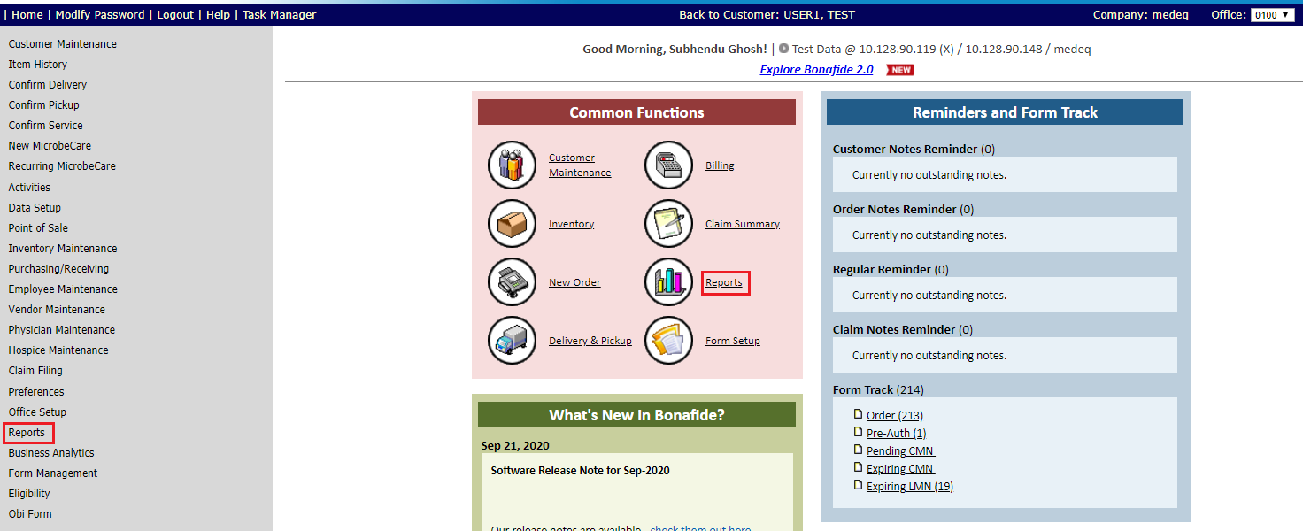

1. Click on “Customer Report(New)” under “Customer” section

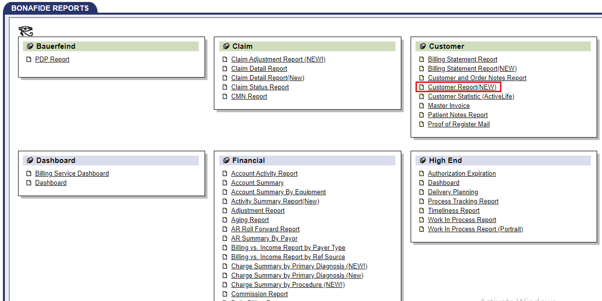

1. Enter Customer ID (Ex-12163), select “ALL” for “Source of Business” .

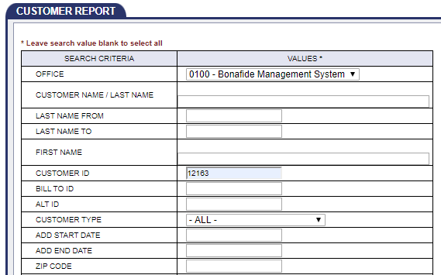

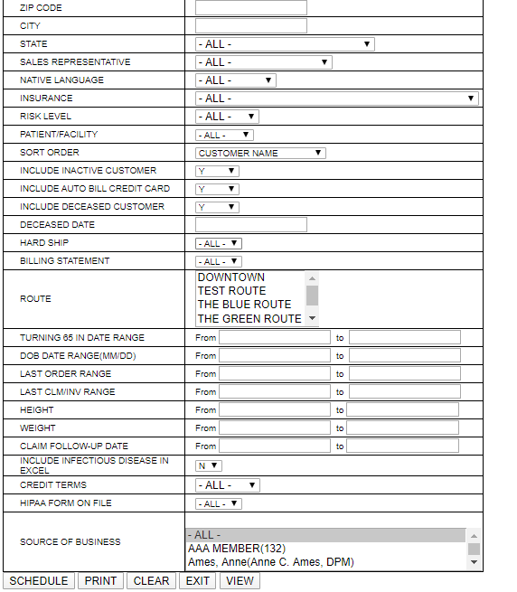

1. Click on “PRINT” button.

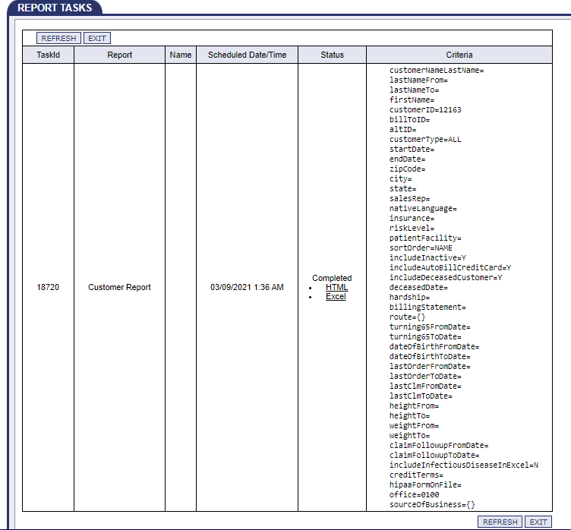

1. Click on “HTML” link to see the report in HTML format.

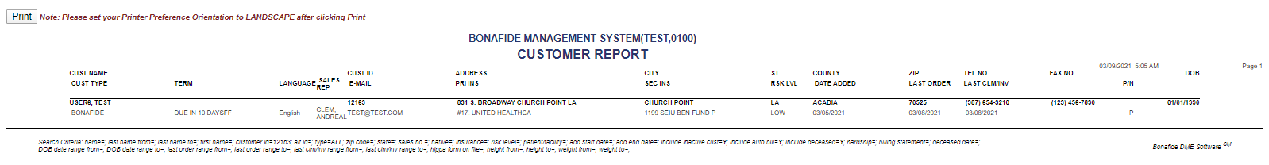

1. Click on “Excel” link to see the report in excel format.

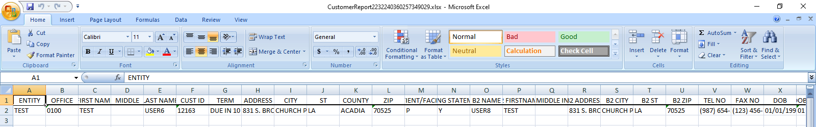

**Customer Order Report-**

1. Click on ” Reports” from the left hand side “Activities” menu or under “Common Functions”



1. Click on “Customer Order Report” under “Customer” section

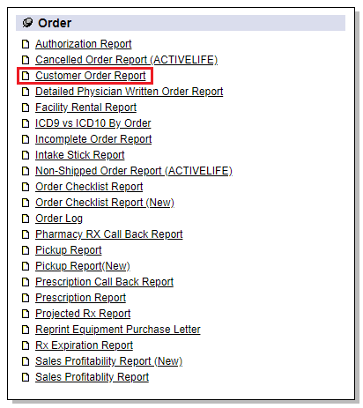

1. Enter Customer ID (Ex-12163), select “ALL” for “Sales Representative”, “EQUIPMENT TYPE (Use CTRL key for multiple)”, “EQUIPMENT SUB TYPE (Use CTRL key for multiple)”

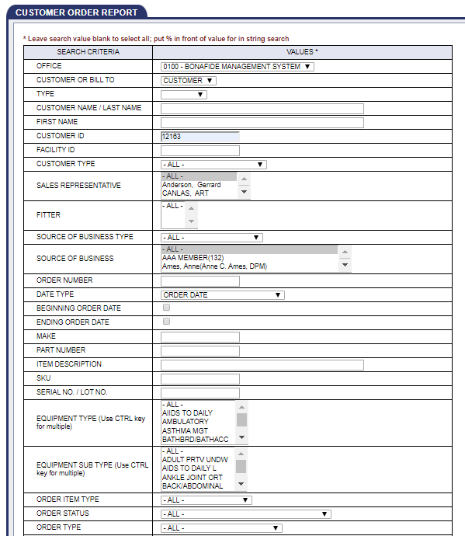

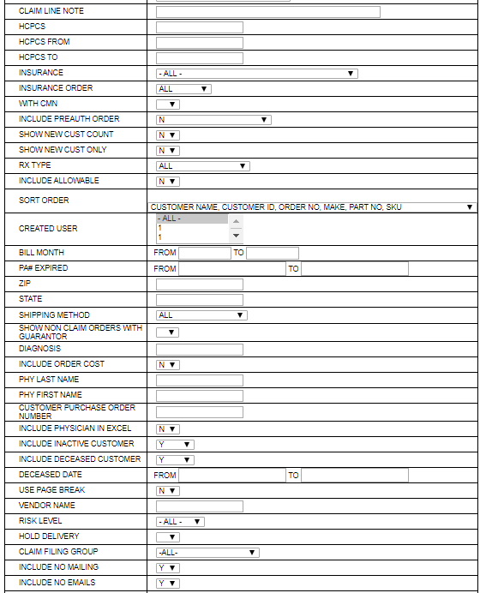

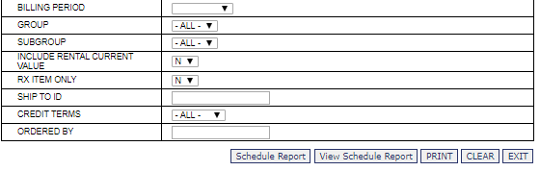

1. Click on “PRINT”

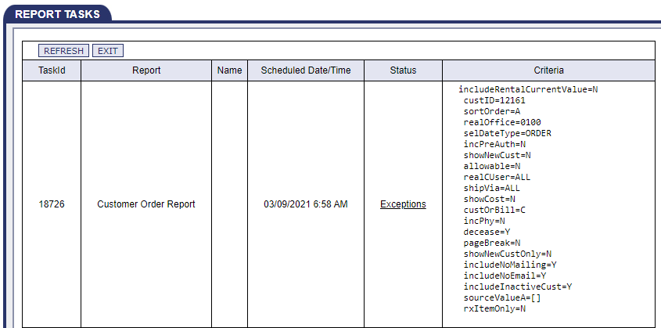

1. Getting Exceptions, but it should not.

**Note**- As there is an issue in QA site, that is why we are getting this Exceptions.